**A MINI PROJECT REPORT ON**

**MY COLLEGE COMPASS**

*in the partial fulfillment of the requirements for the award of the degree of*

**BACHELOR OF TECHNOLOGY**

in

**COMPUTER SCIENCE AND INFORMATION TECHNOLOGY**

**Submitted by**

**NALLAMOTHU AKASH 20B81A3306**

**BHAVIK GOYAL 20B81A3313**

**GANTA RAJASHEKAR 20B81A3331**

Under the guidance of

**Dr. R. RAJA**

Associate Professor



**DEPARTMENT OF COMPUTER SCIENCE AND INFORMATION TECHNOLOGY**

**CVR COLLEGE OF ENGINEERING**

**(*An Autonomous institution, NBA, NAAC Accredited and Affiliated to JNTUH, Hyderabad*)**

Vastunagar, Mangalpalli (V), Ibrahimpatnam (M),  
Rangareddy (D), Telangana- 501 510

**NOVEMBER 2023**

**CVR COLLEGE OF ENGINEERING**

**(*An Autonomous institution, NAAC Accredited and Affiliated to JNTUH, Hyderabad*)**

Vastunagar, Mangalpalli (V), Ibrahimpatnam (M),  
Rangareddy (D), Telangana- 501 510

**DEPARTMENT OF COMPUTER SCIENCE AND INFORMATION TECHNOLOGY**



**CERTIFICATE**

This is to certify that the project report entitled **“MY COLLEGE COMPASS”** bonafide record of work carried out by **NALLAMOTHU AKASH (20B81A3306), BHAVIK GOYAL (20B81A3313)** and **GANTA RAJASHEKAR (20B81A3331)** submitted to **Dr. R. RAJA** for the requirement of the award of **BACHELOR OF TECHNOLOGY** in **COMPUTER SCIENCE AND INFORMATION TECHNOLOGY** to the CVR College of Engineering, affiliated to Jawaharlal Nehru Technological University, Hyderabad during the year 2023-2024.

**Project Guide Project Coordinator**

**Dr. R. RAJA** **Dr. R. RAJA**

Associate Professor Associate Professor

Department of CSE(CS) Department of CSE(CS)

**Head of the Department External Examiner**

**Dr. LAKSHMI H N**

Professor & HOD-CSIT

**DECLARATION**

We hereby declare that the project report entitled **“MY COLLEGE COMPASS”** is an original work done and submitted to CSIT Department, CVR College of Engineering, affiliated to Jawaharlal Nehru Technological University Hyderabad in partial fulfilment for the requirement of the award of Bachelor of Technology in Computer Science and Information Technology and it is a record of bonafide project work carried out by us under the guidance of **Dr. R. RAJA**, Associate Professor, Department of Computer Science and Engineering(Cyber Security).

We further declare that the work reported in this project has not been submitted, either in part or in full, for the award of any other degree or diploma in this Institute or any other Institute or University.

Signature of the Student

**NALLAMOTHU AKASH**

Signature of the Student

**BHAVIK GOYAL**

Signature of the Student

**GANTA RAJASHEKAR**

**Date:**

**Place:**

**ACKNOWLEDGEMENT**

The success and outcome of this project require a lot of guidance and assistance from many people and we are extremely privileged to have got this all along with the completion of our project. All that we have done is only due to such supervision and assistance and we would not forget to thank them.

We respect and thank our internal guide **Dr. R. RAJA**, for providing us an opportunity to do this project work in CVR College of Engineering and giving us all the support and guidance, which made us complete the project duly. We are extremely thankful to him for providing such a nice support and guidance, although he/she had a busy schedule managing the official affairs.

We would like to thank the Head of the Department, Professor **Dr. LAKSHMI H N** for her meticulous care and cooperation throughout the project work. We thank **Dr. R. RAJA**, Project Coordinator for providing us an opportunity to do this project and extending good support and guidance.

We are thankful for and fortunate enough to get constant encouragement, support, and guidance from all **Teaching** **staff of CSIT Department** which helped us in successfully completing our project work. Also, I would like to extend our sincere esteem to all staff in the laboratory for their timely support.

**Abstract**

Entrance exams for college in Telangana such EAMCET is one of the most competitive exams a student can take. Every year, it feels like the competition is only getting tougher, but it is not known for sure. However, the tougher job is to select a proper department from a proper college our rank can fetch. Our project aims at helping the students by providing the college that they have the chance of getting into.

This is the solution provided by the "MY COLLEGE COMPASS" application, which analyzes cutoff ranks based on each college and narrowing it down to the department also. It is an android application implemented using Flutter and Android Studio to harvest and properly analyze the data. The main objective of this project is to give the specific department in a specific college that the user wants to know.

**TABLE OF CONTENTS**

|  |  |  |  |
| --- | --- | --- | --- |
| **Chapter No.** | | **Contents** | **Page No.** |
|  |  | List of Figures | vi |
| 1 |  | **Introduction** | 1 |
|  | 1.1 | Motivation | 1 |
|  | 1.2 | Problem statement | 2 |
|  | 1.3 | Project Objectives | 2 |
|  | 1.4 | Project report Organization | 2 |
| 2 |  | **Literature Survey** | 3 |
|  | 2.1 | Existing work | 3 |
|  | 2.2 | Limitations of Existing work | 4 |
| 3 |  | **Software & Hardware specifications** | 5 |
|  | 3.1 | Software requirements | 5 |
|  | 3.2 | Hardware requirements | 6 |
| 4 |  | **Proposed System Design** | 7 |
|  | 4.1 | Proposed methods | 7 |
|  | 4.2 | Class Diagram | 8 |
|  | 4.3 | Use case Diagram | 9 |
|  | 4.4 | Activity Diagram | 10 |
|  | 4.5 | Sequence Diagram | 11 |
|  | 4.6 | System Architecture | 12 |
|  | 4.7 | Technology Description | 13 |
| 5 |  | **Implementation & Testing** | 14 |
|  | 5.1 | First Screen | 14 |
|  | 5.2 | Implementation | 15 |
|  | 5.3 | Testing | 16 |
|  | 5.4 | Modules | 18 |
|  | 5.5 | Test Case | 20 |
| 6 |  | **Conclusion & Future scope** | 21 |
|  |  | **References** | 22 |

**List of Figures**

|  |  |  |
| --- | --- | --- |
| **Figure No.** | **Title** | **Page No.** |

* + 1. Class Diagram 09
    2. Use Case Diagram 10
    3. Activity Diagram 11
    4. Sequence Diagram 12

4.6.1 System Architecture 13

* + 1. First Screen 15
    2. College List Screen 15

5.3.1 Error 18

5.4.1 Modules 19

5.5.1 Input Screen 21

5.5.2 Output Screen 21

**CHAPTER – 1**

**INTRODUCTION**

“My College Compass” is a user-friendly mobile application designed to assist students in finding suitable engineering colleges based on their EAMCET rank, caste, and gender. The app features a straightforward interface where users can input their details, enabling dynamic filtering of colleges based on specific criteria. Real-time error messages guide users, ensuring accurate data input. Each displayed college includes essential details such as name, branch availability, cutoff rank, and tuition fees, empowering users to make well-informed decisions about their education. My College Compass streamlines the college selection process, providing students with a reliable and efficient tool to explore institutions that align with their academic aspirations and preferences.

* 1. **MOTIVATION**

The motivation behind My College Compass stems from the complexities students often face while choosing the right engineering college. The overwhelming number of options, coupled with varying admission criteria, can make this decision-making process daunting. This application aims to simplify this crucial step in a student's academic journey. By harnessing the power of technology, My College Compass provides a solution that is both efficient and user-friendly.[1] It is motivated by the desire to empower students, ensuring they have access to accurate, up-to-date information that allows them to make well-informed choices about their education. By easing the college selection process, the app strives to reduce stress and provide clarity, enabling students to focus on their aspirations and dreams without being weighed down by the complexities of college selection.

* 1. **PROBLEM STATEMENT**

Selecting an appropriate engineering college is a pivotal decision in a student's academic journey, but the process is often overwhelming and confusing.[2] Students face challenges in navigating through a multitude of options, each with varying admission requirements, cutoff ranks, and tuition fees. The lack of a streamlined and user-friendly platform exacerbates this issue, making it difficult for students to find institutions that align with their EAMCET rank, caste, and gender preferences.[2] There is a critical need for a solution that simplifies this process, providing students with a clear and efficient way to filter colleges based on their specific criteria and empowering them to make well-informed decisions about their higher education.

* 1. **PROJECT OBJECTIVE**

The objective of My College Compass is to provide a streamlined and user-friendly mobile application that simplifies the complex process of choosing an engineering college. By allowing students to input their EAMCET rank, caste, and gender preferences, the app dynamically filters colleges in real-time, presenting a curated list of institutions that match their criteria.[3] The application aims to empower students with accurate, up-to-date information, ensuring transparency and enabling well-informed decisions about their higher education. With intuitive navigation, real-time error handling, and comprehensive college details, the objective is to ease the stress of college selection, helping students focus on their aspirations and educational goals without the burden of complicated decision-making processes.

* 1. **PROJECT REPORT ORGANIZATION**

The project report for My College Compass is structured systematically, beginning with an introduction that outlines the application's purpose, motivation, and the problem it addresses. [4] A literature review explores similar applications and market trends, while requirements analysis delves into user stories and detailed functional requirements. The design section elucidates the system's technical aspects, including architecture, database schema, and user interface design. Implementation details the code structure and algorithms used, highlighting challenges and solutions. The testing section covers methodologies and results, leading to a discussion on user feedback and comparisons with similar apps. The report concludes with a summary of achievements, challenges, and future enhancements, followed by references, appendices with screenshots and code snippets, and acknowledgments to contributors and mentors.

**CHAPTER – 2**

**LITERATURE SURVEY**

**2.1 EXISTING WORK**

While the specific application My College Compass might not have existed at that time, there were several existing platforms and applications catering to the college selection process. Websites like CollegeDekho, Shiksha, and Careers360 provided comprehensive databases of colleges, including details like cutoff ranks, fees, and reviews. Mobile apps like Collegedunia offered similar services on the go. These platforms often included features for filtering colleges based on various criteria, aiding students in making informed decisions.

Additionally,[4] educational boards and government portals in countries like India typically provided official websites with detailed information about colleges, entrance exams, and admission procedures. These platforms aimed to simplify the college selection process by centralizing information.

While these resources existed, the unique selling point of My College Compass could be its real-time dynamic filtering, user-friendly interface, and potential focus on specific regions or universities, catering to a more localized and personalized experience for students.

**2.2 LIMITATION OF EXISTING WORK**

**2.2.1 Data Accuracy:** The data provided by existing platforms might not always be up-to-date or accurate. Changes in admission criteria, fees, or courses might not be promptly reflected.

**2.2.2 Limited Customization:** While existing platforms offer filters, the level of customization might be limited.[3] They might not cater to specific regional preferences or nuanced criteria that students might have.

**2.2.3 User Experience:** Some platforms might have a complex user interface, making it challenging for users, especially those not familiar with technology, to navigate through the information effectively.

**2.2.4 Lack of Real-Time Updates:** Information updates might not happen in real-time, causing students to potentially miss out on last-minute changes in cutoff ranks or admission procedures.

**2.2.5 Inadequate Reviews:** While some platforms have review sections,[2] the number and quality of reviews might be limited, providing insufficient insights for students to make decisions.

**2.2.6 Insufficient Counselling:** While data is valuable, students often need expert guidance and counselling during the college selection process,[1] which might not be adequately provided by online platforms.

**2.2.7 Limited Scope:** Some platforms might have a limited scope, focusing mainly on popular colleges or universities, leaving out valuable options that could be suitable for specific students.

**2.2.8 Device Dependency:** Many platforms are accessible primarily via websites or mobile apps, potentially excluding students with limited internet access or those from remote areas.

**2.2.9 Inconsistency in Criteria:** [1] Different platforms might present the same data differently or use varying criteria for ranking colleges, leading to confusion among students.

**CHAPTER – 3**

**SOFTWARE AND HARDWARE SPECIFICATONS**

**3.1 SOFTWARE REQUIREMENTS**

**3.1.1 Development Tools**

* **Android Studio:** For Flutter-based cross-platform development.
  + 1. **Framework**
* **Flutter:** Google's UI toolkit for building natively compiled applications for mobile, web, and desktop from a single codebase.
  + 1. **Programming Language**
* **Dart:** For flutter-based cross-platform development.
  + 1. **Data source**
* **Kaggle:** Online community platform to find the desired datasets.
  + 1. **Data Parsing**
* The dataset is parsed into csv file to extract the data.
  + 1. **Operating System**
* **Windows:** Windows 10 or later is recommended.
* **macOS:** macOS 10.14 (Mojave) or later.
* **Linux:** Most distributions are supported. Ubuntu is a popular choice for Flutter development.

**3.2 HARDWARE REQUIREMENTS**

**3.2.1 Computer**

* **Processor:** Any modern multi-core processor (e.g., Intel Core i5, AMD Ryzen 5, or equivalent) is sufficient for development purposes.
* **RAM:** At least 4 GB of RAM is recommended. Higher RAM capacity can improve the performance, especially when running multiple applications simultaneously.
* **Storage:** SSD (Solid State Drive) is preferred over HDD (Hard Disk Drive) for faster read/write speeds, which can significantly enhance the performance of development tools and simulators/emulators.

**3.2.2 Mobile Devices**

* A physical Android or iOS device is not strictly required for development, but having at least one real device for testing can be immensely helpful to assess real-world performance and user experience.
* Emulators/Simulators: Android Emulator (part of Android Studio) for Android app testing and the iOS Simulator (part of Xcode) for iOS app testing.

**3.2.3 Internet Connection**

* A stable internet connection is essential for downloading necessary packages, libraries, and updates during the development process.

**CHAPTER – 4**

**PROPOSED SYSTEM DESIGN**

**4.1 PROPOSED METHODS**

**4.1.1 User Input Gathering**

* Implement a screen to collect user input, including EAMCET rank, caste, and gender. Implement validation to ensure correct input format and range.

**4.1.2 Data Parsing**

* Develop logic to parse data from the provided CSV or Excel file. This includes creating a ‘College’ class or struct to hold the parsed data and converting the raw data into these objects.

**4.1.3 Filtering Logic**

* Implement filtering logic based on user input. Filter the list of colleges based on the entered EAMCET rank, caste, and gender. Apply appropriate comparison logic (greater than or equal to) for cutoff ranks.

**4.1.4 Result Display**

* Design a screen to display the filtered list of colleges. Present this information in a readable format, possibly in a list or card view, providing details like college name, branch, and tuition fee.
  + 1. **User Experience Enhancement**
* Implement user-friendly features like real-time validation for input fields (such as indicating when a valid EAMCET rank is entered), ensuring smooth navigation between screens, and providing clear error messages for incorrect inputs.
  + 1. **Error Handling**
* Implement robust error handling mechanisms for scenarios such as invalid input or file parsing issues. Provide user-friendly error messages to guide users in case of mistakes.

**4.2 CLASS DIAGRAM**

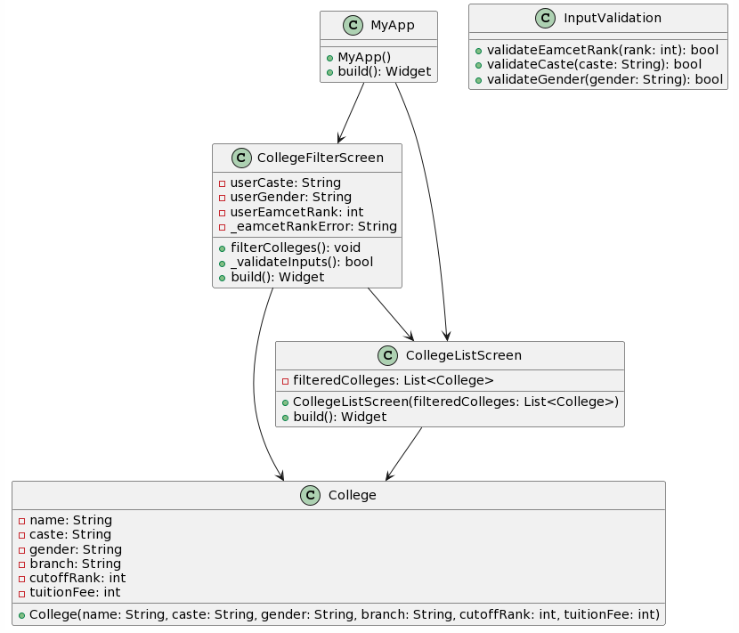

Fig.No. 4.2.1: Class Diagram

The class diagram for the “My College Compass” application encapsulates three fundamental classes: "CollegeFilterScreen", the main screen where users input their EAMCET rank, gender, and caste preferences, along with methods for input validation and filtering initiation; "CollegeListScreen", responsible for displaying the filtered list of colleges, receiving and presenting filtered college data, and managing user interactions with individual colleges; and "College", a data model class representing individual colleges, storing details such as name, caste, gender, branch, cutoffRank, and tuitionFee. These classes exhibit relationships denoting the flow of data and control: "CollegeFilterScreen" communicates with CollegeListScreen to pass filtered college data, and both classes depend on the College class for college-related data handling. This diagram provides a clear overview of the application's architecture, illustrating the relationships and interactions among core components.

**4.3 USE CASE DIAGRAM**

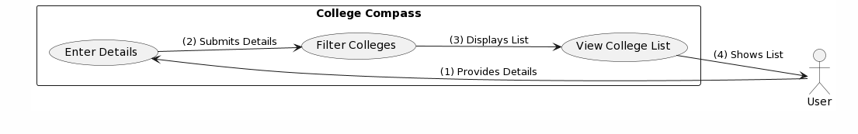Fig.No. 4.3.1 Use Case Diagram

The Use Case Diagram for My College Compass illustrates the various interactions between external actors and the application. The primary actors are User and System. User initiates the process by interacting with the application, providing inputs such as EAMCET rank, caste, and gender. The application then validates and processes this information. The System encompasses the essential use cases: Input College Preferences, where the user inputs their EAMCET rank, caste, and gender; Filter Colleges, wherein the system filters the colleges based on user preferences; and Display College List, displaying the filtered list back to the user. Additionally, there's Display Error Messages, ensuring the user is informed in case of invalid inputs. These use cases represent the core functionalities, outlining the interactions between the user and the application system.

**4.4 ACTIVITY DIAGRAM**

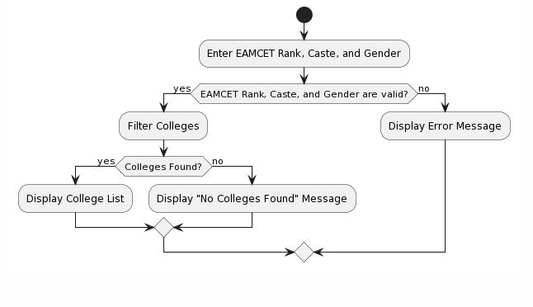

Fig.No. 4.4.1: Activity Diagram

The Activity Diagram for My College Compass succinctly represents the flow of activities within the application. It commences with the Start node, signifying the initiation of the process. The flow progresses to Input College Preferences, where the user inputs their EAMCET rank, caste, and gender. Subsequently, the application validates this input. If the input is valid, the system moves to Filter Colleges, where it processes the user's preferences and filters the colleges accordingly. In case of invalid input, the flow redirects to Display Error Message node, informing the user of the error. After filtering, the system proceeds to Display College List, where the user can view the filtered colleges. The diagram concludes at the End node, indicating the completion of the process. This visualization provides a clear understanding of the sequential activities and decision points within the application, ensuring a smooth user experience.

**4.5 SEQUENCE DIAGRAM**

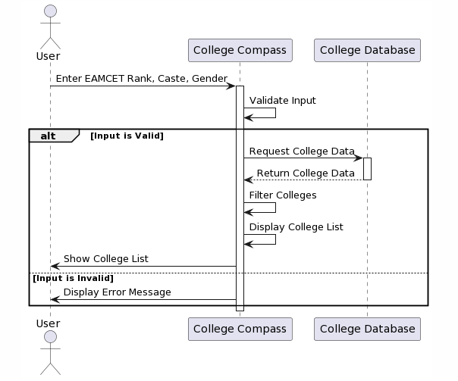

Fig.No. 4.5.1: Sequence Diagram

The Sequence Diagram for My College Compass delineates the interactions and message flow between various components of the system during the process of filtering and displaying college results. Initiated by the User, the sequence starts with the Input College Preferences message, denoting the user's input of EAMCET rank, caste, and gender. If valid, the system sends a Filter Colleges message, which includes the user preferences, to the Colleges Database. The database responds by filtering the colleges based on the given criteria, and the filtered results are returned to the system as a Filtered Colleges List message. Finally, the System sends a Display College List message to the User Interface, which displays the filtered colleges to the user. This sequence illustrates the dynamic interactions between the user, system components, and the database, outlining the flow of information within the application.

**4.6 SYSTEM ARCHITECTURE**

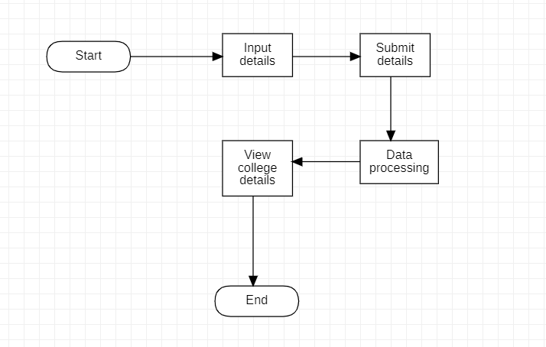

Fig.No. 4.6.1: System Architecture

The System Architecture of My College Compass is designed as a client-server model. The client side comprises the user interface, responsible for gathering user preferences and displaying filtered results. The server side involves the backend logic, managing the filtering process and interacting with the colleges' database. The client, representing the user, initiates the process by inputting their EAMCET rank, caste, and gender through the intuitive user interface. This input is sent to the server, which houses the core logic for filtering colleges based on the provided criteria. The server communicates with the colleges' database, retrieving relevant data for processing. Once the colleges are filtered, the server sends the refined results back to the client, which then displays the colleges to the user. This architecture ensures a seamless flow of information, allowing users to efficiently access tailored college options based on their preferences.

**4.7 TECHNOLOGY DESCRIPTION**

**Flutter**, an open-source UI framework backed by Google. Flutter ensures a consistent and visually appealing user experience across various platforms, including Android and iOS, using a single codebase. The application's logic is scripted in **Dart**, an object-oriented programming language optimized for front-end development, enhancing the app's performance and responsiveness.

The application incorporates **CSV parsing technology**, allowing efficient handling of structured data. This feature enables the app to import and process data from CSV files seamlessly, facilitating tasks such as reading college information, including names, cutoff ranks, branches, and fees. By leveraging CSV parsing, My College Compass optimizes data management and enhances user interactions.

To maintain an intuitive and user-friendly interface, the app adheres to the principles of **Material Design**, Google's design language for creating cohesive and visually appealing apps. Material Design ensures a modern and consistent look, enhancing user engagement and interaction.

My College Compass prioritizes a smooth user experience through dynamic form validation, input length restrictions, and intelligent button states. By implementing these features with Flutter's robust UI components and event handling mechanisms, the application ensures error-free user inputs and enhances usability.

**CHAPTER – 5**

**IMPLEMENTATION AND TESTING**

**5.1 FIRST SCREEN**

* It consists of fields where user can input their rank, caste and gender.
* They have limitations like the user can enter up to 6 digits.
* Only numbers are allowed to enter, not any other characters.

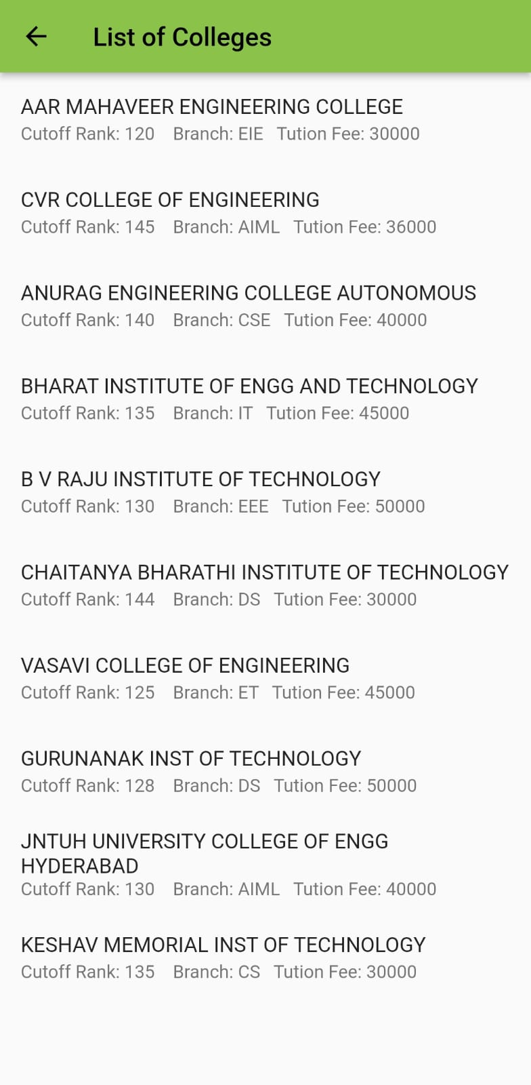 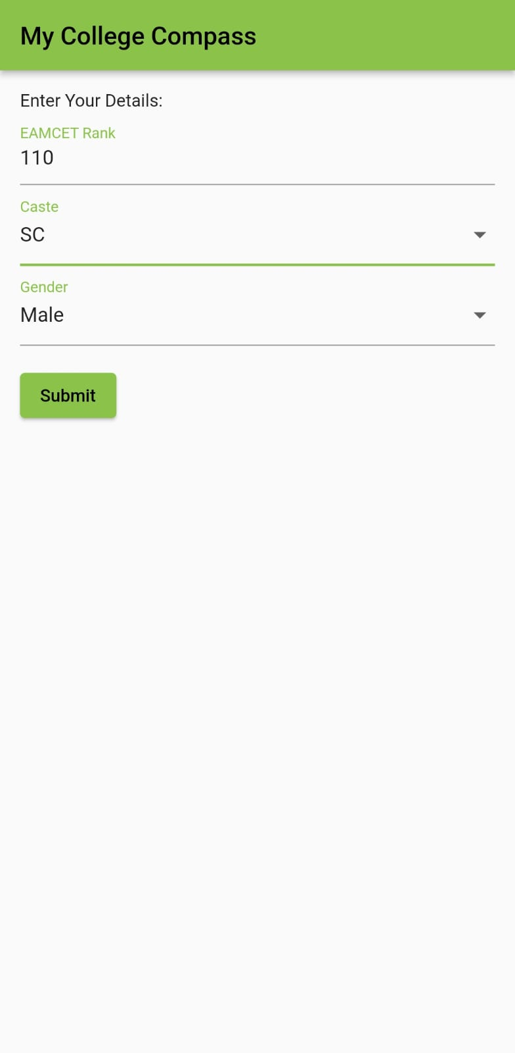

Fig.No. 5.1.1: First Screen Fig.No. 5.1.2: College List Screen

**5.2 IMPLEMENTATION**

“My College Compass” is implemented using Flutter, a versatile and powerful open-source UI framework, and Dart, a modern programming language. The application's frontend logic is organized into modular widgets, promoting code reusability and maintainability.

* + 1. **User Interface Design**

The app's user interface is designed following Material Design guidelines, ensuring a cohesive and visually pleasing experience. Key components, such as input fields for EAMCET rank, dropdown menus for gender and caste, and interactive buttons, are implemented using Flutter widgets. Input validation mechanisms guarantee that users provide accurate data, enhancing the reliability of the app.

* + 1. **Data Management**

Structured college data, including names, cutoff ranks, branches, and fees, is efficiently handled through CSV parsing. This allows the app to import data from CSV files seamlessly, facilitating quick and accurate information retrieval.[3] Dart's data processing capabilities are harnessed to manipulate and filter this data based on user inputs.

* + 1. **Navigation and Screens**

The app utilizes Flutter's navigation system to transition between screens. After the user submits their data, the app navigates to the CollegeListScreen, displaying colleges that match the user's criteria. Each college's details are presented in a structured format, enhancing readability and user comprehension.

* + 1. **User Experience and Testing**

Throughout the implementation process, the app undergoes rigorous testing.[1] User experience is a priority, and the app is fine-tuned for responsiveness, ensuring seamless interactions on both Android and iOS devices. Iterative testing and feedback loops contribute to an intuitive user interface and a bug-free experience.

**5.3 TESTING**

**5.3.1 Unit Testing**

* Individual functions and modules are rigorously tested in isolation to verify their correctness. Dart's unit testing framework is employed, allowing developers to assess the behavior of specific code segments, ensuring they produce the expected outputs for given inputs. Unit tests cover critical functionalities such as input validation, data processing, and filtering algorithms [4].

**5.3.2 Widget Testing**

* Widget testing in Flutter's testing framework is utilized to validate the behavior of UI components.[1] Widget tests verify the rendering of widgets, user interactions, and the response of the interface to different inputs. This level of testing ensures that the app's components are displayed correctly and that they respond appropriately to user actions.

**5.3.3 Integration Testing**

* Integration tests focus on evaluating the interactions between different modules and components of the application. These tests validate the seamless integration of individual units, ensuring they work together as expected.[1] Flutter's integration testing framework facilitates testing the entire app or specific sections, guaranteeing the correct flow of data and navigation.

**5.3.4 User Interface Testing**

* UI testing is crucial for validating the user experience. Flutter's built-in testing tools enable developers to create automated tests that simulate user interactions. These tests ensure that the app's UI elements, such as input fields, buttons, and dropdowns, function as intended.[2] UI tests also validate the app's responsiveness across various devices, screen sizes and checks for the error in the input section.

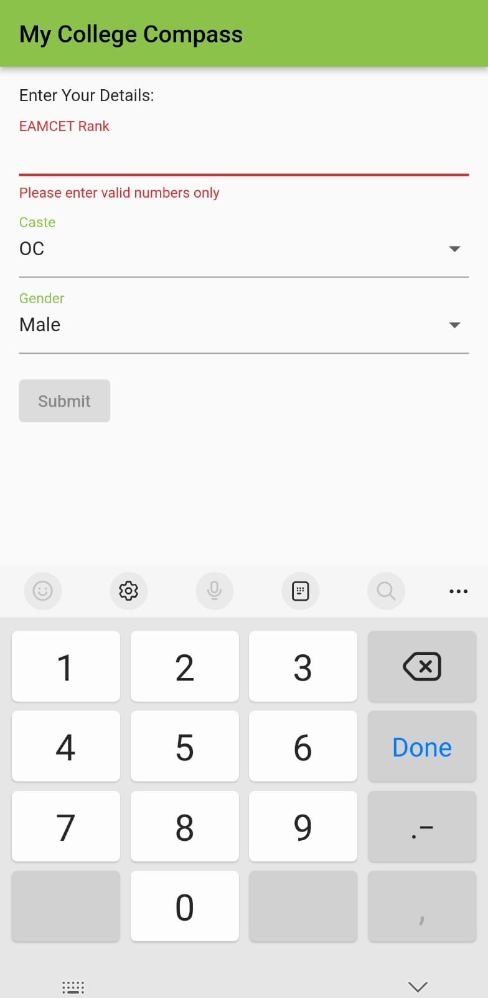

Fig.No. 5.3.1: Error

**5.3.5 End-to-End Testing**

* End-to-End (E2E) testing simulates real user scenarios and verifies the application's behavior from start to finish. Flutter's E2E testing capabilities allow developers to automate user interactions across multiple screens and validate the entire user journey. E2E tests are particularly valuable for assessing complex workflows, such as form submissions and data processing.

**5.4 MODULES**

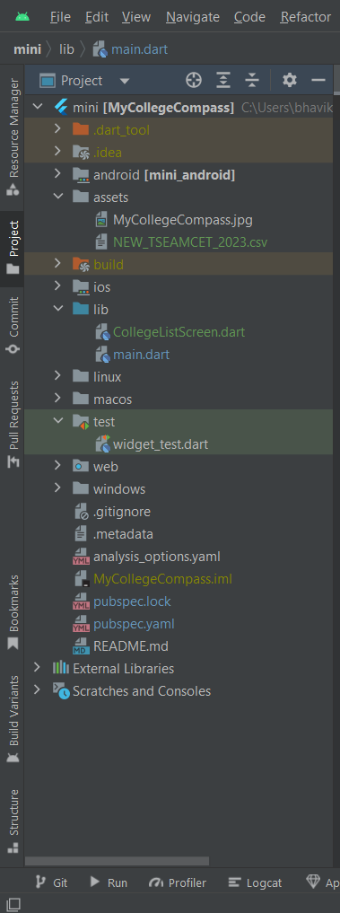

Fig.No. 5.4.1: Modules

**5.4.1 User Input Model**

* **Description:** This module handles user input for EAMCET rank, gender, and caste preferences.
* **Implementation:** Utilizes Flutter's “TextField” and “DropdownButtonFormField” widgets for capturing user data. Input validation ensures accurate information.
  + 1. **Filtering Module**
* **Description:** This module filters the list of colleges based on user preferences (EAMCET rank, gender, and caste).
* **Implementation:** Utilizes Dart programming logic to filter the colleges list. It checks the user input against college data and creates a filtered list.
  + 1. **Data Display Module**
* **Description:** This module is responsible for displaying the filtered list of colleges to the user.
* **Implementation:** Utilizes Flutter's “ListView” or “GridView” widgets to present the colleges' information. Each item in the list/grid corresponds to a college object.
  + 1. **Error Handling Module**
* **Description:** This module manages errors and validations related to user input.
* **Implementation:** Utilizes Flutter's error handling mechanisms to display validation errors to the user when incorrect or incomplete data is entered.
  + 1. **Styling and Theming Module**
* **Description:** This module focuses on the visual aspects of the application, including colors, fonts, and overall theme.
* **Implementation:** Utilizes Flutter's Theme Data and custom styles to create a visually appealing and consistent user interface. Widgets are styled using themes and colors.
  + 1. **CSV Parsing Module**
* **Description:** This module is responsible for reading data from the CSV file, parsing it, and converting it into usable objects.
* **Implementation:** Utilizes Dart packages like csv to parse the CSV file. The parsed data is converted into college objects, which are then used in the application.
  + 1. **Navigation Module**
* **Description:** This module handles screen navigation, enabling the transition between input screen and college list screen.
* **Implementation:** Utilizes Flutter's Navigator class to push and pop screens based on user actions. Allows seamless movement between different sections of the app.
  1. **TEST CASE**

**5.5.1 Setup:** Launch the “My College Compass” application.

* + 1. **Input:** Enter a valid EAMCET rank, select a gender, and choose a caste from the dropdown menus.
    2. **Action:** Click the "Submit" button.
    3. **Expected Output:** The application should navigate to the college list screen, displaying colleges that match the user's input criteria. All displayed colleges should have cutoff ranks greater than or equal to the user's input EAMCET rank and should match the selected gender and caste preferences.



Fig.No. 5.5.1: Input Screen Fig.No. 5.5.2: Output Screen

**CHAPTER – 6  
CONCLUSION AND FUTURE SCOPE**

**6.1 CONCLUSION**

In conclusion, My College Compass stands as a powerful tool tailored for students embarking on their higher education journey. By seamlessly integrating user inputs, robust data processing, and intuitive UI, the application simplifies the daunting task of college selection. Its streamlined interface ensures a user-friendly experience, enabling students to filter and explore colleges based on their EAMCET rank, caste, and gender. The application not only provides valuable insights into suitable colleges but also fosters informed decision-making, empowering students to make choices aligned with their aspirations and academic goals.

**6.2 FUTURE SCOPE**

The future scope of My College Compass is vast and promising. Advanced filters like college preferences and specific courses, coupled with real-time data integration, will enhance precision in college recommendations. Enabling side-by-side college comparisons, and fostering community interaction will enrich user experience. Collaboration with colleges and educational portals can provide comprehensive information and additional resources, elevating the app's value. Implementing data analytics will offer insights for continuous refinement. Together, these enhancements will transform My College Compass into an all-encompassing, dynamic tool, ensuring students receive the most tailored, up-to-date, and supportive guidance throughout their educational journey.

**REFERENCES**

[1] Zhenru Wang and Yijie Shi, "Prediction of the admission lines of college entrance examination based on machine learning," 2016 2nd IEEE International Conference on Computer and Communications (ICCC), Chengdu, China, 2016, pp. 332-335, Doi: 10.1109/CompComm.2016.7924718.

[2] P. K. Binu, A. Chandran and M. Rahul, "A Cloud-Based Data Analysis and Prediction System for University Admission," 2019 2nd International Conference on Intelligent Computing, Instrumentation and Control Technologies (ICICICT), Kannur, India, 2019, pp. 1327-1332, doi: 10.1109/ICICICT46008.2019.8993328.

[3] S. Sridhar, S. Mootha and S. Kolagati, "A University Admission Prediction System using Stacked Ensemble Learning," 2020 Advanced Computing and Communication Technologies for High Performance Applications (ACCTHPA), Cochin, India, 2020, pp. 162-167, doi: 10.1109/ACCTHPA49271.2020.9213205.

[4] S. P. Singh, P. Singh and A. Mishra, "Predicting Potential Applicants for any Private College using LightGBM," 2020 International Conference on Innovative Trends in Information Technology (ICITIIT), Kottayam, India, 2020, pp. 1-5, doi: 10.1109/ICITIIT49094.2020.9071525.

**PLAGIARISM REPORT**

|  |  |  |  |
| --- | --- | --- | --- |
| **Chapter No.** | **Chapter Name** | **Number of words** | **Plagiarism** |
| 1 | Abstract | 141 | 0% |
| 2 | Introduction | 585 | 0% |
| 3 | Literature Survey | 400 | 0% |
| 4 | Software and Hardware Specifications | 259 | 17% |
| 5 | Proposed System Design | 1110 | 0% |
| 6 | Implementation and Testing | 986 | 0% |
| 7 | Conclusion and Future Scope | 188 | 0% |
| **Total:** | | 3669 | 17% |

Note: “Duplichecker” plagiarism tool is used for checking chapter-wise plagiarism.

Duplichecker — <https://www.duplichecker.com/>